LEARNING REPORT

One1Spot

Mathematical Partner

Contents

Activity 1 3

Topic: One1Spot – Mathematical partner 3

REQUIREMENTS: 3

High Level Requirements: 3

Low Level Requirements: 4

System Design: 4

Structural Design: 4

Behavioural Design: 5

6

Test Plans : 7

High Level Test plan 7

Low Level Test Plan 7

Implementation: 8

# Activity 1

## Topic: One1Spot – Mathematical partner

## REQUIREMENTS:

### High Level Requirements:

* Choice opted by user must be executed.
* Perfect Values must be generated for each operation.
* Consistency of value must be ensured for al iteration

### Low Level Requirements:

* Using C language for making executable files.
* GCC compiler required for running the files.
* Code blocks IDE for code editing.
* Usage of functions for individual workfows.

## System Design:

### Structural Design:

Component Diagram:

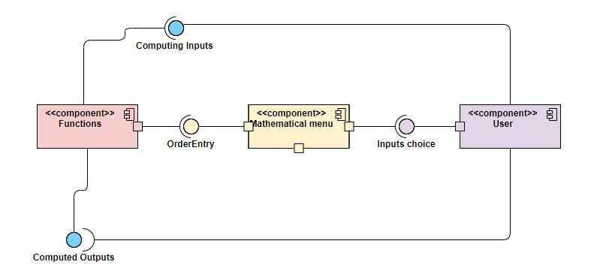

Deployment Diagram:

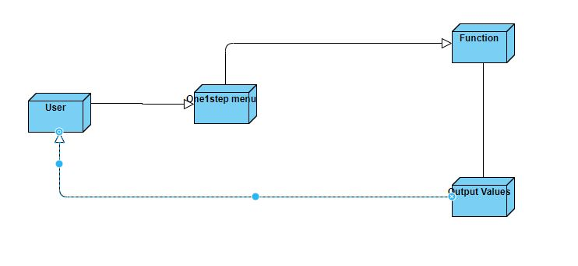

Behavioural Design:

User case :

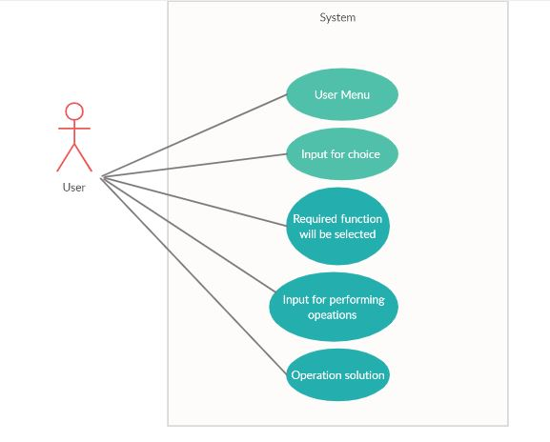

Activity Diagram :

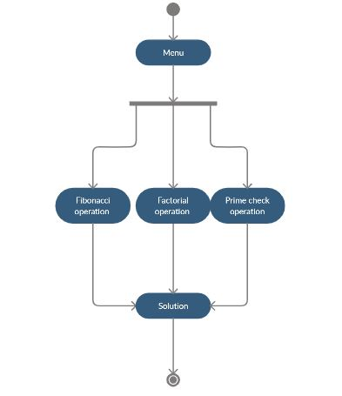

Test Plans :

High Level Test plan

|  |  |  |  |  |
| --- | --- | --- | --- | --- |
| **ID** | **Description** | **Expected I/P** | **Expected O/P** | **Actual O/P** |
| 1 | User choices | The choice of operation required. | Operational input box opens |  |
| 2 | Perfect output for given input | Values for operation must be read | Calculated output must be displayed |  |
| 3 | Consistency of output |  | Output for required limit must be displayed |  |

Low Level Test Plan

|  |  |  |  |  |
| --- | --- | --- | --- | --- |
| **ID** | **Description** | **Expected I/P** | **Expected O/P** | **Actual O/P** |
| 1 | Read choice and validate | If its within list of choice | Choice of operation must be opened. |  |
| 2 | Read choice and validate | If it’s not in list. | Exit |  |
| 3 | Check no of parameters passed | Parameters for calculation. | Output for the calculated parameters |  |
| 4 | Check the integer is prime | Positive Integer | Check whether its prime or not and provide output |  |
| 5 | Print Fibonacci Series | Limit of series | Print the Fibonacci series till the limit |  |
| 6 | Print Factorial of integer | Positive Integer | Print the Factorial of the integer. |  |

Implementation:

Github Link : https://github.com/stepin104308/Onespot1

Screenshot :

